M06 Chapter 11 Hands On Submission
- Hands-On Project 11-1
  - For Public Route Servers, you may use the following sites, as the one from the book is no longer available:
    - https://tools.keycdn.com/bgp-looking-glassLinks to an external site.
    - https://www.bgplookingglass.com/Links to an external site.
    - https://lg.routeviews.org/Links to an external site.
    - https://www.routeservers.org/Links to an external site.
  - Screenshot of route summary (step 3)
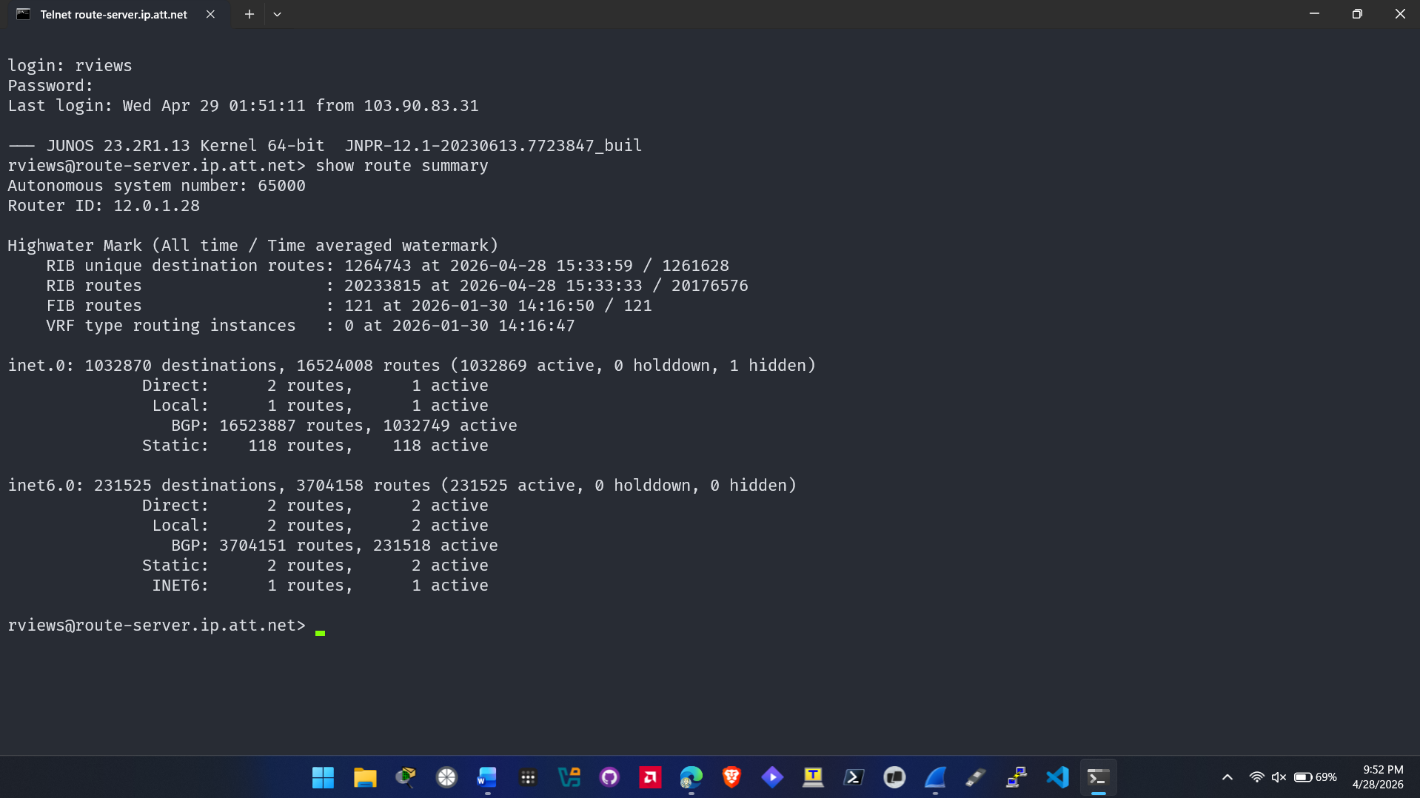
  - Screenshot of route extensive (step 4)
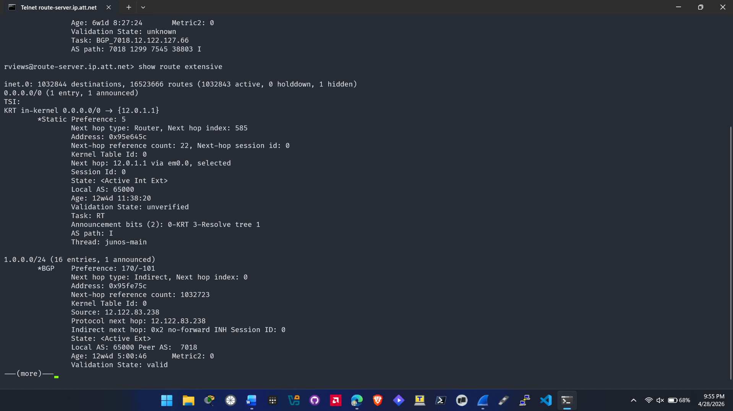
  - Screenshot of route table (step 5)
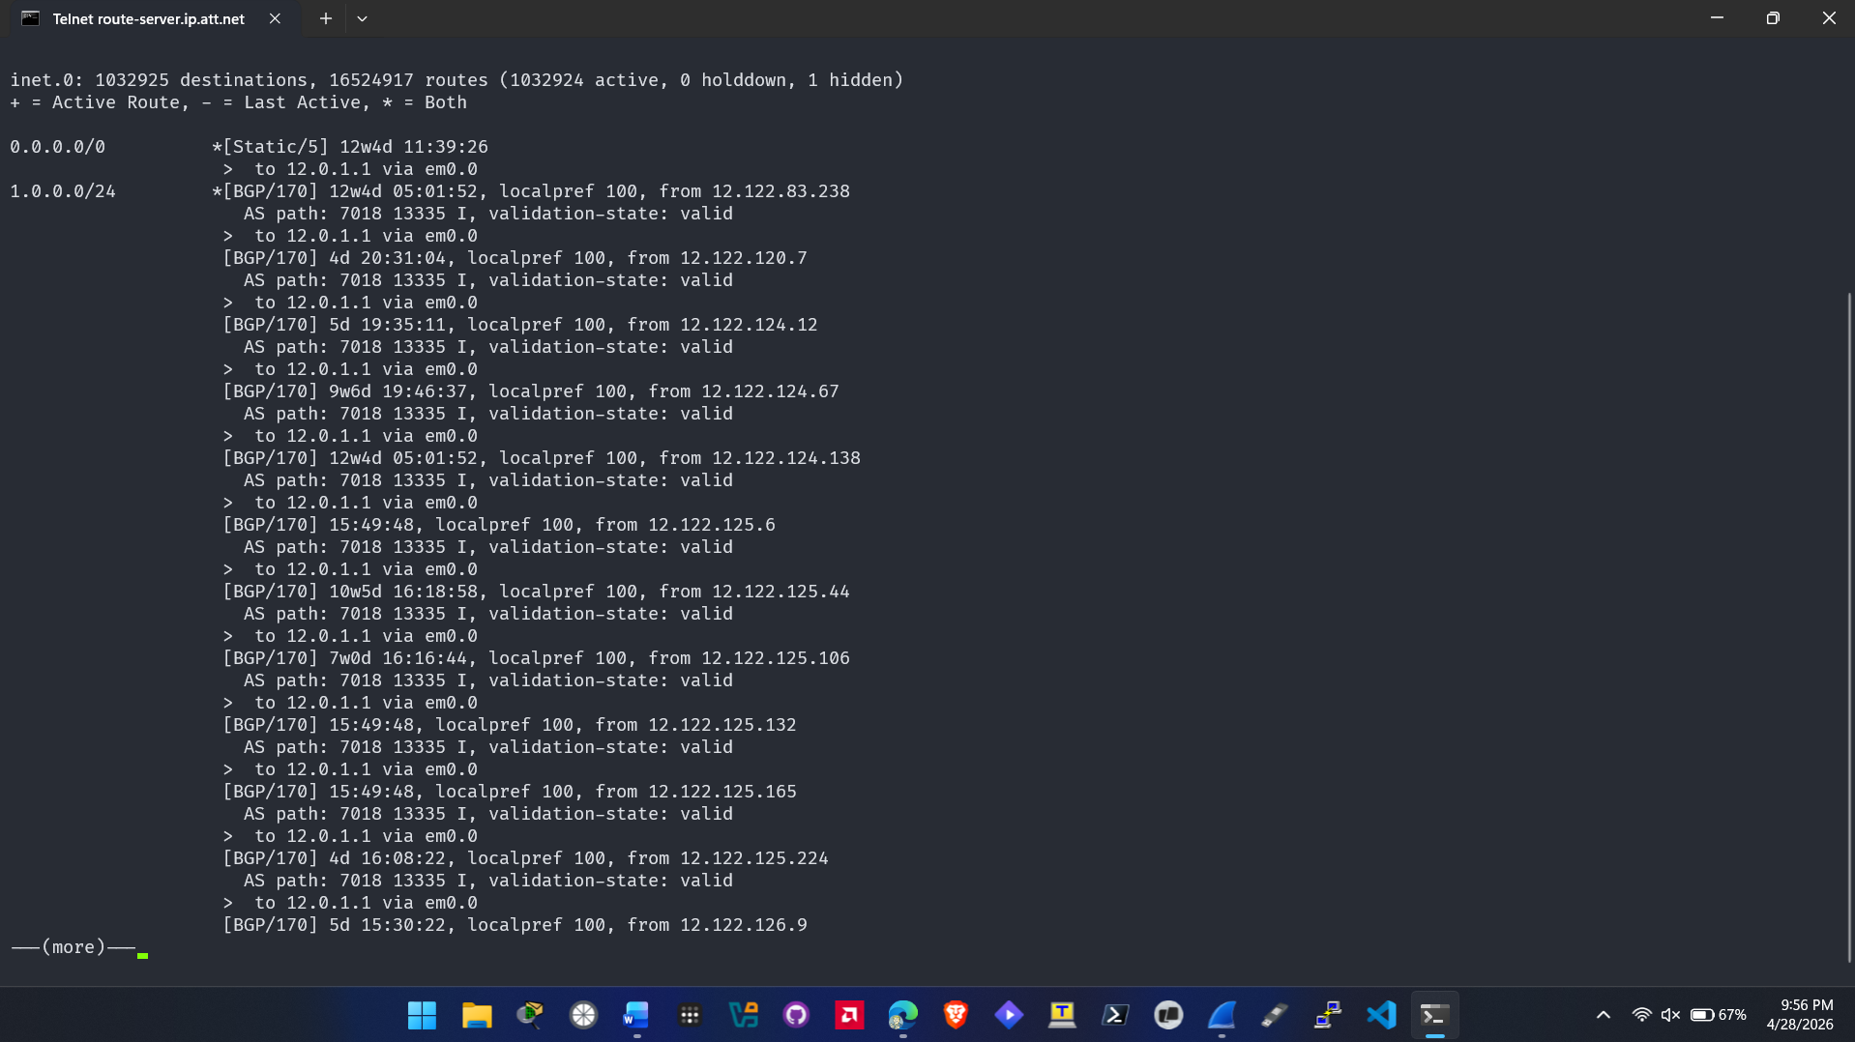
  - Screenshot of route table IPv6 (step 6)
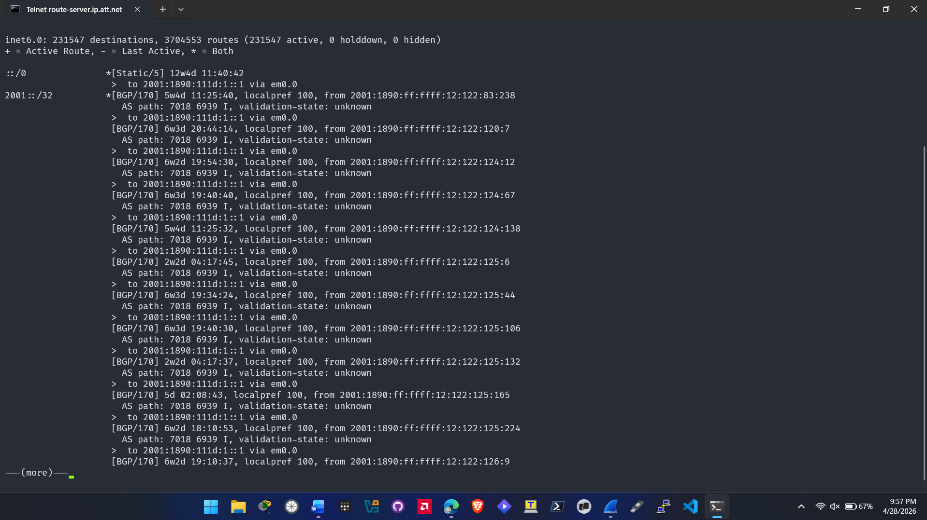

  - Screenshot of bgp summary (step 7)
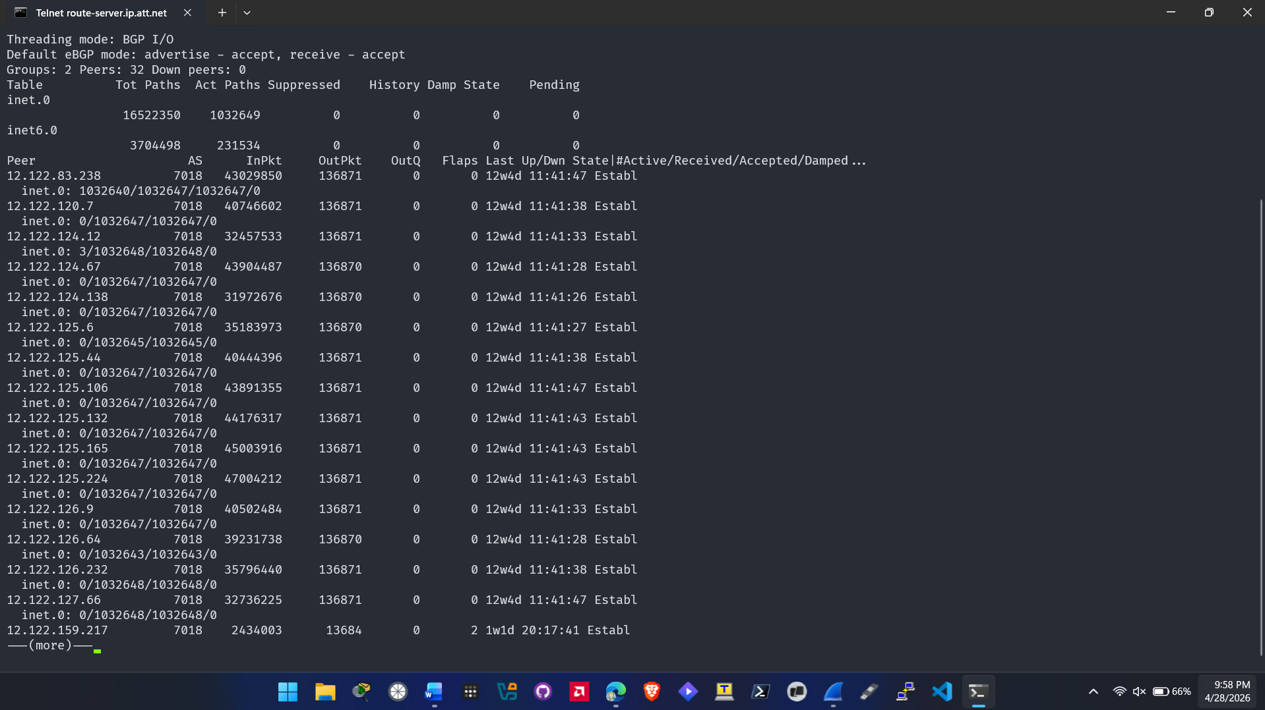
  - Screenshot of bgp summary (step 8)
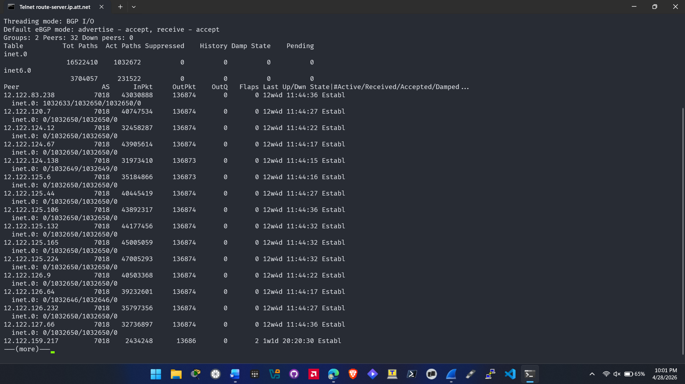

  - Screenshot of show command output (step 9)
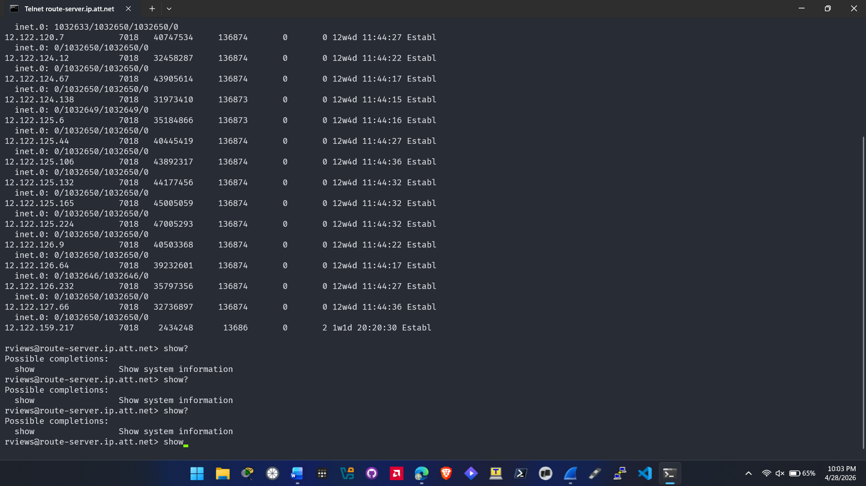
- Hands-On Project 11-2
  - Screenshot of netsh output (step 2)
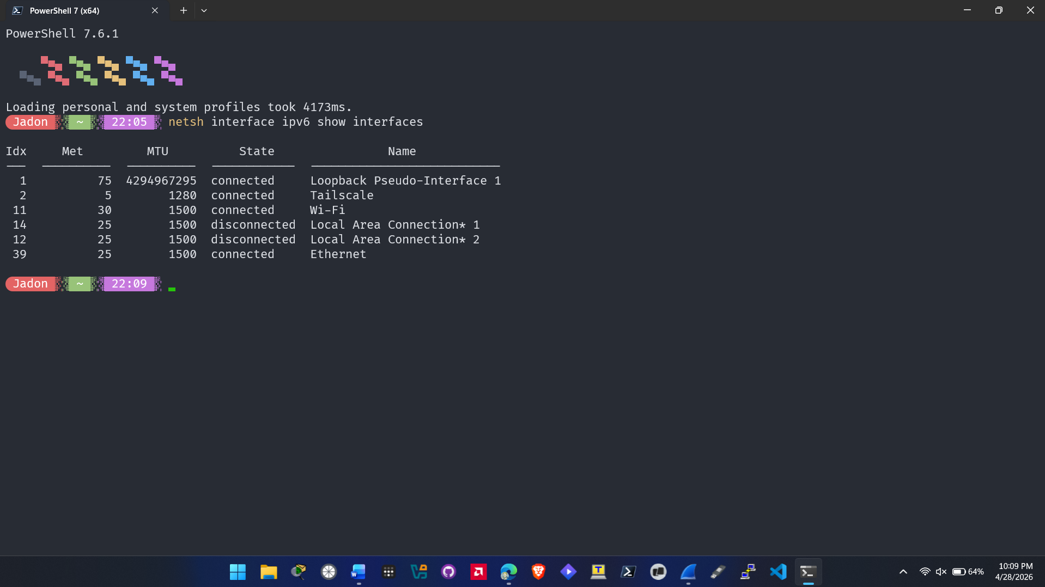

  - Screenshot of netsh output (step 3)
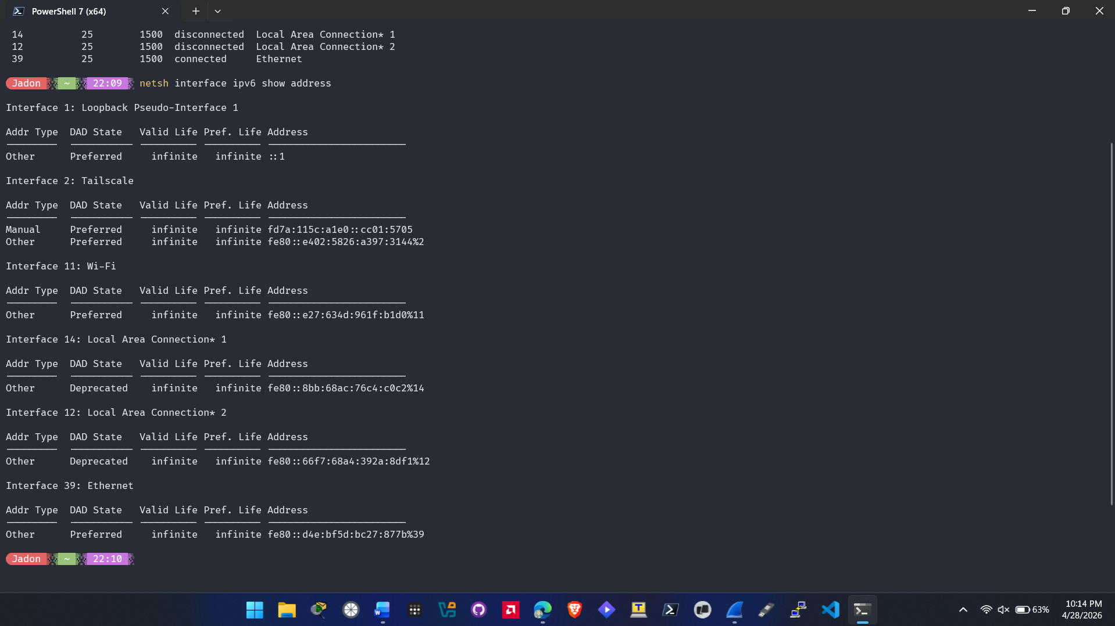
  - Screenshot of netsh output (step 4)
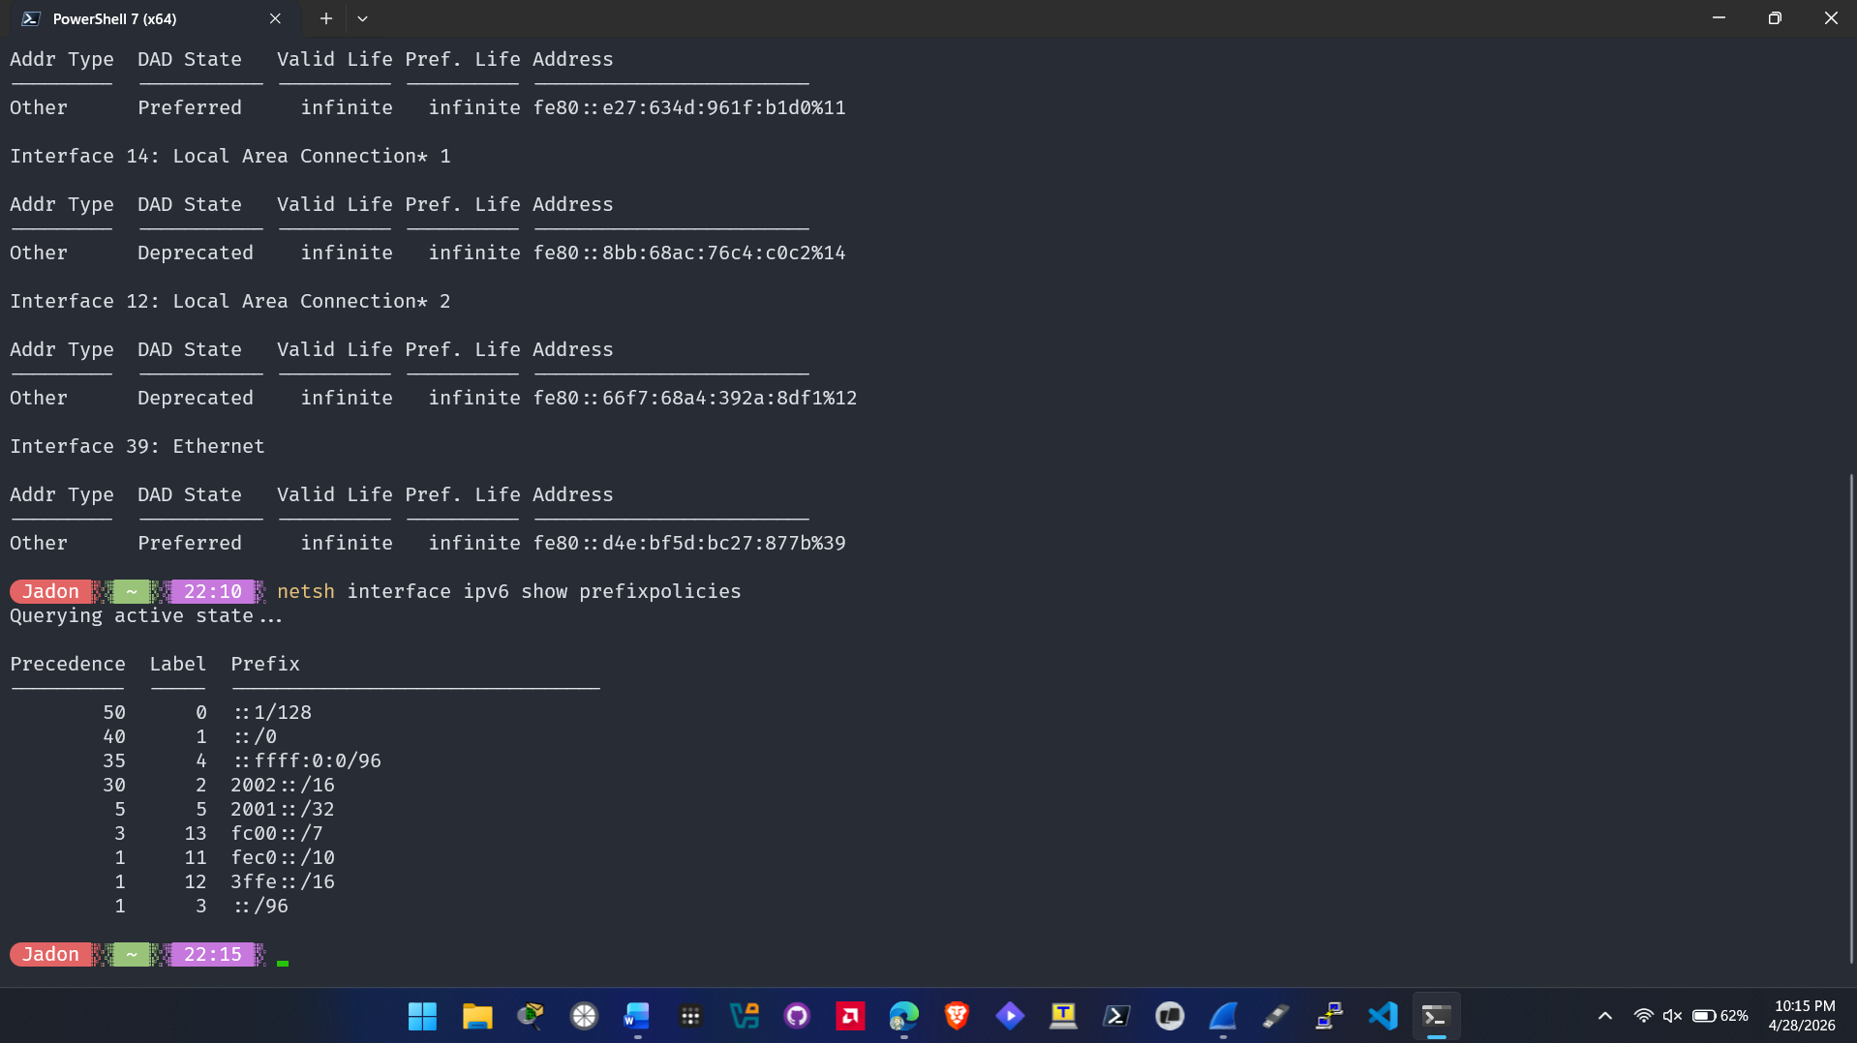

  - Screenshot of netsh output (step 5)
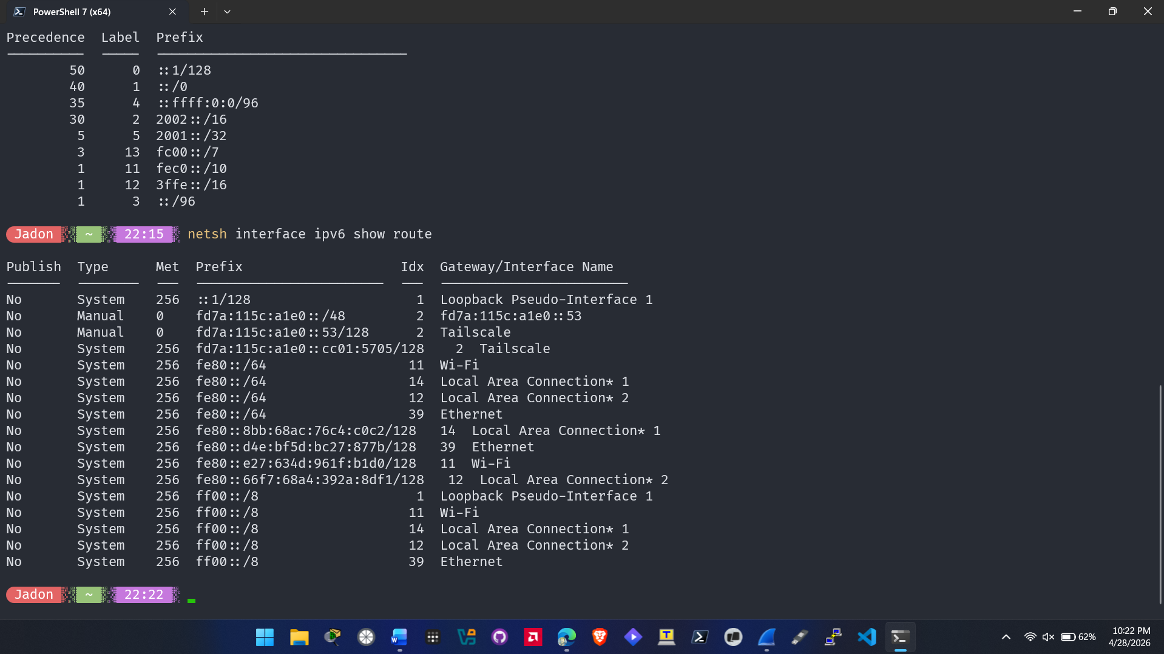
  - Screenshot of netsh output (step 6)
